NCHV Logo & Usage Guidelines
Please refer to this guide to help you create materials using the NCHV Boots Brigade brand for your fundraiser.

Are you authorized?
This Style Guide is meant to support the efforts of volunteers who are raising money to benefit the National Coalition for Homeless Veterans as part of NCHV Boots Brigade, and have agreed to the Volunteer Fundraiser Agreement during the signup process. It does not, on its own, grant you permission to use our logos. Vendors, partners, contractors, and other third parties must have a written contract or permission specifically authorizing such use. For questions, volunteers should consult NCHV.

What are the rules?
- Always follow this style guide.
- When you register for NCHV Boots Brigade, you are agreeing to our terms of logo usage. Never use a logo unless you are a registered participant.
- Never misuse a logo or bring it or NCHV into disrepute.
- Use the logo only in a manner consistent with NCHV’s mission.
- Never use a logo for commercial purposes, without written permission.
- Don't add to or subtract from the logo. This includes by changing the layout of text, altering its appearance, stretching, or changing proportions.
- Don’t place the logo too close to an edge.
- Don’t place on a busy background.
- Don’t add a glow, drop shadow, or outline.

By using these logos, you also acknowledge that NCHV is their sole owner, and promise not to interfere in any way with NCHV’s rights in them. All goodwill derived from your use of the logos accrues to NCHV. NCHV has the absolute right to revoke permission to use its logos at any time, with or without a reason.

What logo can I use to promote my fundraiser?
You may use the logo below when promoting your event.

Logo
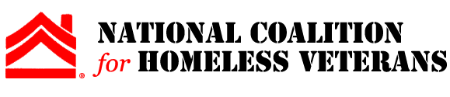
Download Logo
You are not permitted to imply that NCHV is hosting, partnering, or sponsoring your event.

Language to use in promotion:
When promoting your event, please use the following language:
I am fundraising as a part of NCHV Boots Brigade to benefit the National Coalition for Homeless Veterans, a nonprofit organization dedicated to ending veteran homelessness.
When promoting proceeds, please use the following language:
The proceeds from my fundraiser will benefit the National Coalition for Homeless Veterans, a nonprofit organization dedicated to ending veteran homelessness.

